Project 2: Bop It

Team Beta: Anthony Caamano, Connor Ferry, Alexander Haver

Final Report

**Design Overview**

Our Bop It design includes three separate inputs. They are a joystick, push button, and slide potentiometer. There are four commands that the user will need to act to progress in the game. They are push (button), slide (potentiometer), and rotate clockwise and counterclockwise (joystick). The user will hear and see the actions to be performed by a specific audio cue and on an LCD display. There is a specific amount of time for which the user must perform the action. If the user does not perform in time, or incorrectly performs the action; they lose a life. Once they lose three lives, their score is recorded, and they are presented with a screen that says, “You Lose!”. If the user can successfully get a score of 99, then the screen displays “You Win!”. In addition to this standard game mode, we have a hard mode in which only the audio signals are used to dictate the action and the allowed time between actions is shortened.

**Design Verification**

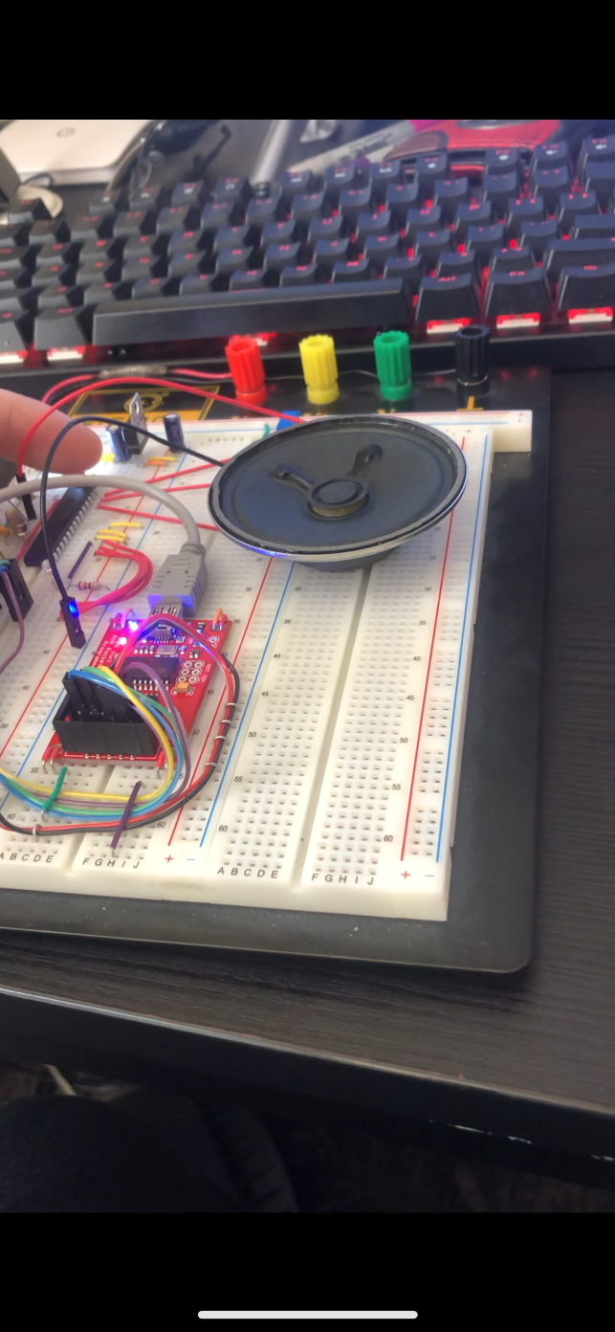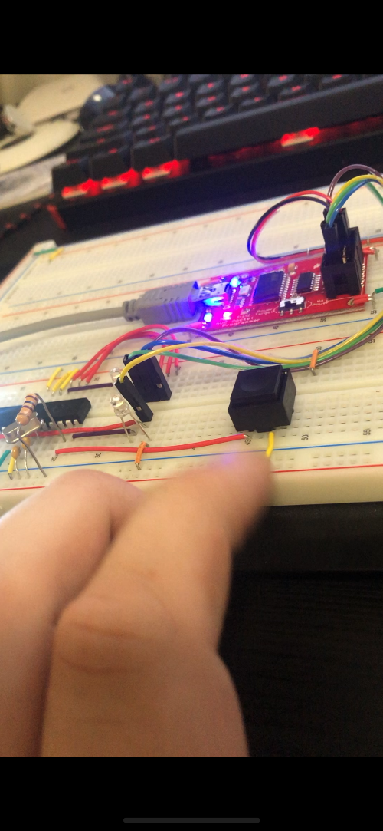 As a result of the delayed shipping of the parts, we had to improvise when it came to design verification. We had ordered five or six possible inputs and we had originally planned to test all of them and see what worked, what did not, and what felt nice. Unfortunately, because of the delay, we had to move forward with testing using components we had on hand. Luckily between stuff from old labs and the parts we could salvage from old projects we were able to figure out which of our hypothetical inputs would be possible with the parts we ordered. We were extremely lucky that Alex had a smaller version of the microphone we had intended on using because if he hadn’t, we wouldn’t have known that it needed an extra amplifier chip to work until after the final bill of materials. Our testing consisted of using a breadboard to connect every part we had access to individually and seeing if we could get it to work the way we wanted to. We will only be including a few pictures of test setups, but this is the full list of parts we tested in this fashion and what parts they corresponded to:

* Push button
* Potentiometer (slide, joystick, encoder)
* Speaker
* Buzzer
* Microphone
* LED’s (7 segment & decoder)

Before the first parts order came in, we had proof of concept prototypes for all three of our inputs and almost all the rest of our hardware. The input prototypes would turn on an LED if the action were already preformed and another LED once the timer expired. These prototypes meant that when the parts came in and the board was assembled the only changes that would have to be made were fine tuning and bug fixes. The only piece of hardware that never had an official prototype program was the LCD display and that is because the manufacturers posted a library of examples. That said, we still ended up using the screen to create an early concept for the lives counter before the board was fully assembled. Pictures from a recording of that are below.

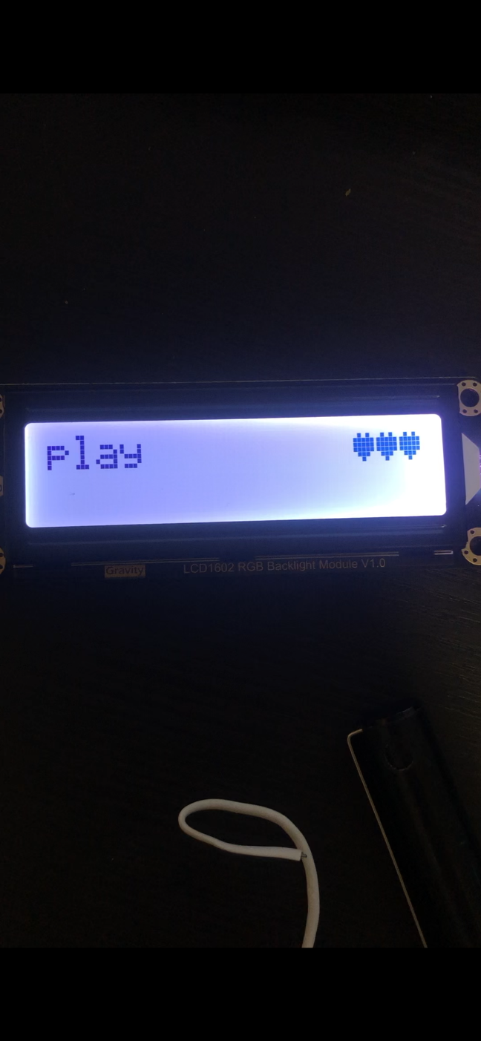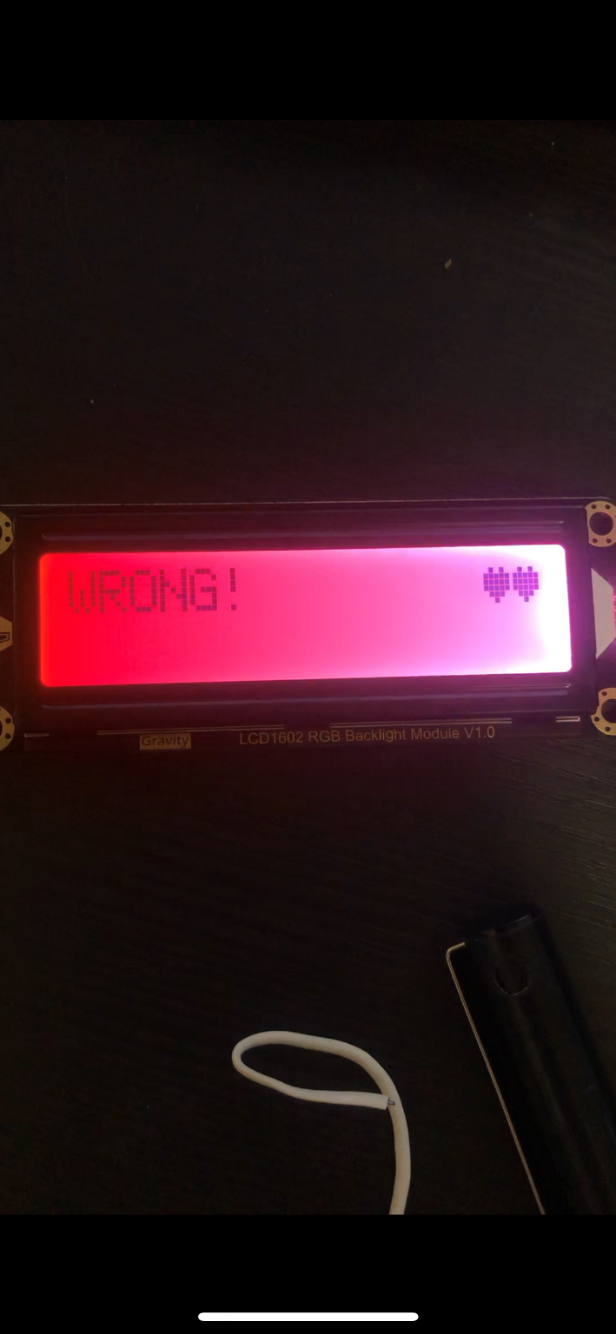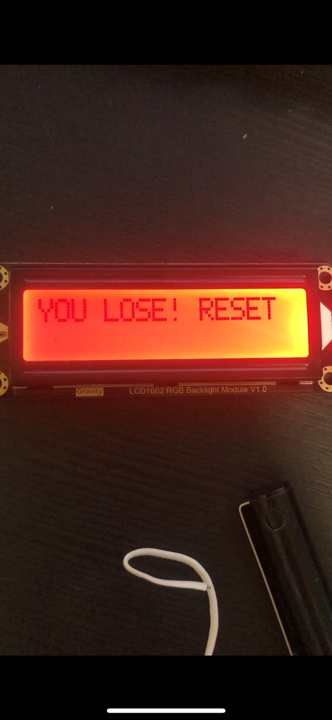

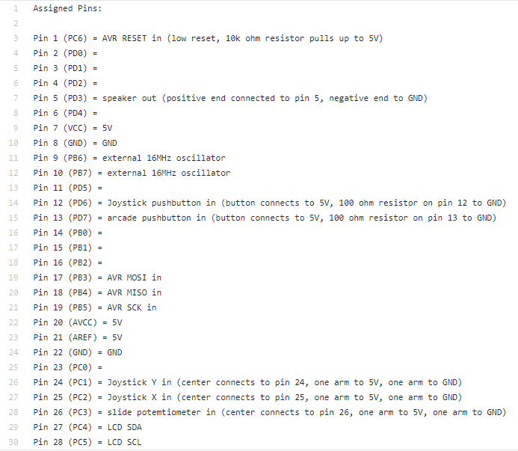

**Electronic Design Implementation**

The design implementation of the hardware for our bop it started in the previous design verification state. In this state, we experimented with different inputs and outputs to see what worked well. During this process, we compiled a list of all the pins on the ATMega328 that we were using and what component was connected to it. This list allowed us to properly allocate pins to different analog or digital signals from different components. The final version of this list is pictured on the right.

Now, with this list of pins we were going to use, we were able to begin the design of our circuit. To start laying out our circuit, we first had to choose individual parts that we would eventually use on the final soldered PCB. We used a combination of Altium Designer’s built in part search function as well as DigiKey’s online part search. The basic composition for picking a part went as follows: If the component is either a low wattage resistor or a non-electrolytic capacitor, pick a 1206 SMD component. Any other part that was on the original ATMega328 circuit from class, pick the same component. Parts that fell into this category were components like the ATMega IC, the oscillator crystal, and the electrolytic capacitor on either side of the voltage regulator. For the rest of the components, if there was a surface mount option that was not too small, we picked that part.

Next, we had to decide how we wanted to be able to flash the chip once it was on the board. Two suggestions from class were to either make the chip removable or add headers to the board to be able to plug the programmer in to. We opted for both suggested options. Our thinking was that the headers on the PCB would allow for easy flashing without having to continually remove the chip and place it in another circuit purely designed for flashing it. We also thought that making the IC removable would allow us to interchange the chip if something happened to it (like frying).

After this, we started the circuit design by downloading all the schematic diagrams/PCB footprint for all the parts. We placed all the parts on the schematic sheet and wired all the parts according to both the original Arduino on a breadboard circuit as well as the previously mentioned pinout. A final version of our schematic is pictured below. Note all the net labels of pins from the IC socket diagram that are not connected.

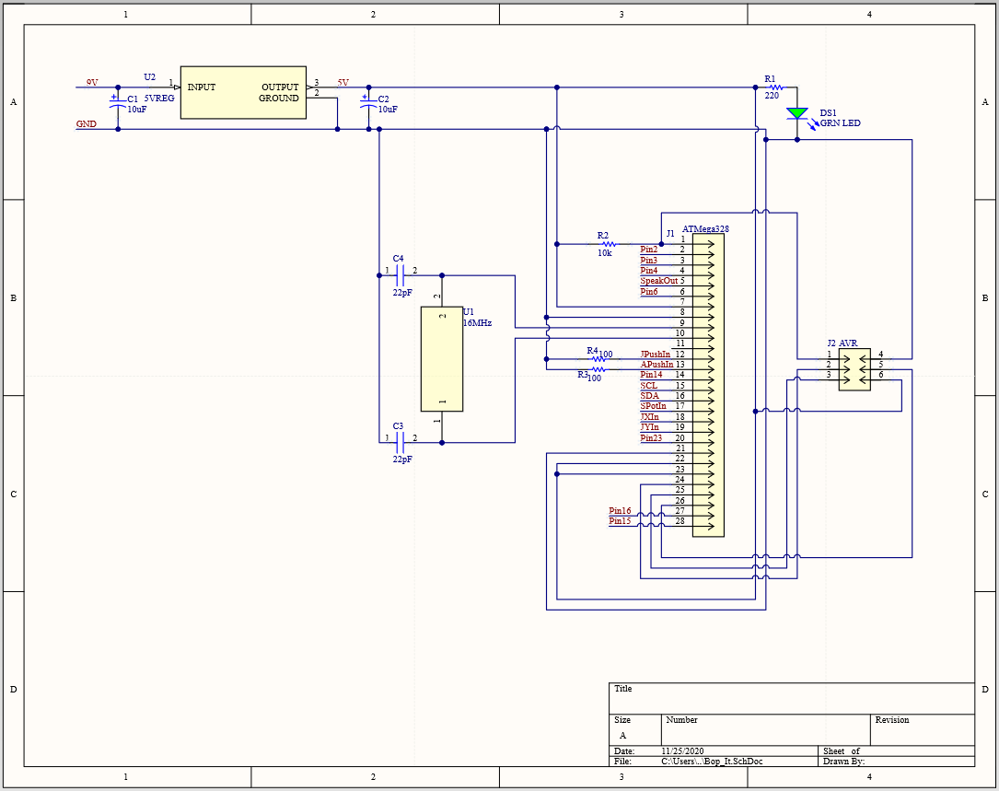

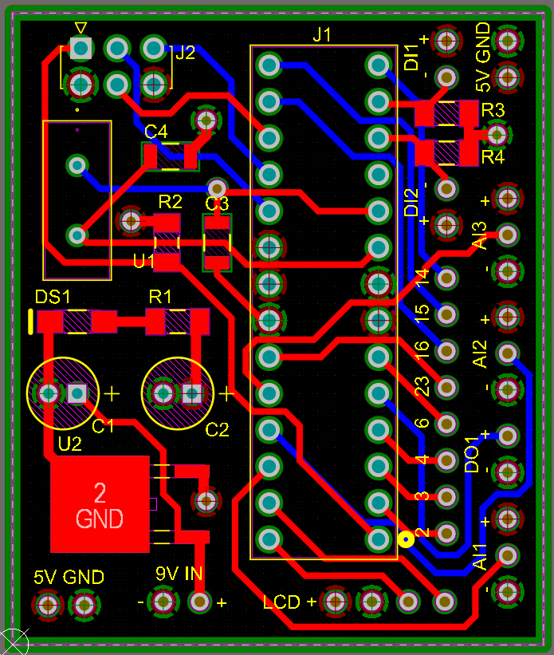 With our circuit schematic finalized, we then started work on our actual PCB design. The first part of this design was to download the rules file for the manufacturer we would end up using: ALLPCB. After incorporating the rules file, it was on to start positioning all the footprints on the board. During this process, we decided we did not want to directly solder the inputs and outputs of our bop it directly to the board (for obvious reasons). Due to this decision, we implemented a row of headers along the side of the board for plugging in such devices. (See left). It was sometime during this process that we realized how large our board would be due to both the number of components and the number of traces between components. Although our original design used plenty of traces on both the top and bottom layer as well as vias connecting the two, we weren’t happy leaving the board size how it was (because in the end this was supposed to be a handheld toy!). We took a deeper look into our layout of traces and realized most of our components used either VCC, GND, or both. Due to this realization, we changed our board type to be a 4-layer board. This took some time to research and perform in Altium, but the final product allowed us to condense all our components together. After the completion of the PCB, we created the corresponding Gerber files and submitted both those files and our final BOM to Canvas. The final layout of our PCB is pictured on the left.

**Software Implementation**

Though our software is not actually implemented as a state machine we will be using the state concept to more easily explain how our program works. But before we do that, we are first going to briefly talk about all the functions and subroutines we have in our main code. We cannot go through each one in depth here so we will just be covering a few, but we will link our GitHub at the end of this section if you’d like to look at any of it. The first function is one written by a fellow named Walter Anderson that generates a truly random seed. The URL of the original site is at the top of our main but essentially Mr. Anderson very cleverly uses the watchdog timer interrupt to generate a truly random number which we use to seed the rand() function. We generate the seed at power on so that every play session will have an unpredictably random set of instructions. We implemented a handful of functions that update the display and background values. Functions in this category include update and display functions for score, high score, and life counters as well as a debug mode that prints the live values of all our input devices. We have functions that test for a particular input, play its corresponding audio and visual cues, and output Boolean value that corresponds to a pass or failure. The pass conditions are obvious but these functions output failures if the user runs out of time or preforms the wrong input. The joystick has a special lose condition which is an incorrect input sequence. The way the joystick function tests for the correct rotation is by recording the sequence of joystick directional inputs (using another small direction detection function) and seeing if that sequence matches one of the four possible input sequences for a given rotation. This means that if the user were to wiggle the joystick back and forth instead or rotating it the function would detect a sequence of “ up down up down” or “left right left right” and return a failure. Now that we have covered all the functions, it’s time to talk about the overall code structure. Like we said above, its most useful to divide our program into three distinct states. The first state is the “Pre-Game” state. As the name implies, this is where all the out of game activities occur. Such activities include displaying the high score from the play session as well as a greeting message. This is also the state from which the user can access debug mode as well as the “Hard mode” mentioned in the design overview. The next state is the “In-Game” state. This is where the user gets to play the game. A random input is chosen, and its corresponding test function is called. The last state is the “Pass/Fail” state. This state takes the output of the test function and displays the corresponding pass of fail message to the screen. This is also where the lives and score are updates and redisplayed. From here, the user either gets put back into the “In-Game” state if they have lives left or into the “Pre-Game” state if they do not. As far as coding practices, we opted to use GitHub to keep track of all the code additions and updates. Even though the code was primarily written by one person we thought it was best that all test codes and main iterations were commented and uploaded to the GitHub so that we could more easily keep the hardware in sync.

GitHub link: <https://github.com/agh37/1895-Bop-It>

**Enclosure Design**

For our enclosure we decided to go with using a 3d printer. We came to this conclusion because it would allow us to easily design around our specific parts. For example, our joystick had three different sets of wire connections on different side of its base. Using 3d modeling and printing made it very easy for us to fit the joystick to the box. We used Fusion 360 to model the enclosure since it is beginner friendly and nobody had prior experience using 3d modeling software. We decide to try and make the enclosure as simple as possible as to decrease the likelihood of the printer failing to print the design properly. To make final assembly easier, we made the walls of the box 10mm thick and made recessions in the walls where we wanted to place the different components. In the picture in the upper right, you can see the recession that we made for the joystick. The final size of the base box was 120x80x60mm. We attached the slide potentiometer, button, joystick, and key switch on the base of the box. The box has a rectangular hole which the PCB, battery, and speaker rests in. In addition, we made a lid which has a rectangular protrusion under it which fits into the hole at the top of the box. When connected, they are held together by friction. Our LCD screen is placed on the lid, so it is easily visible during gameplay. The cables that connect the LCD to the PCB get threaded through the 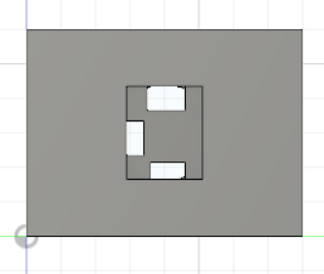bottom of the lid and are long enough so that the lid can be removed without disconnecting the screen from the PCB. To manufacture the enclosure, we exported the main body and lid designs to .stl files and used the 3d printers on the 12th floor of Benedum with the help of William McGahey to get them made. 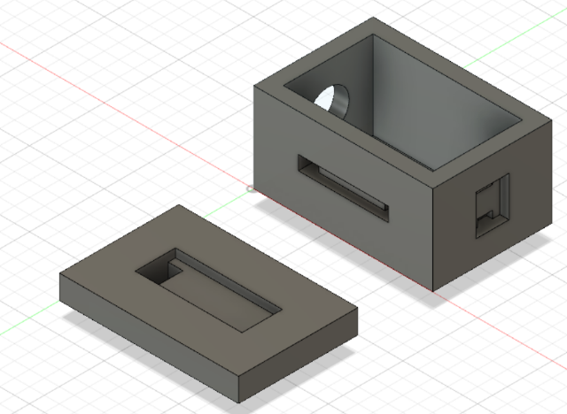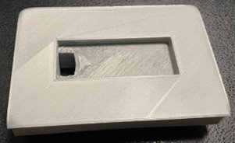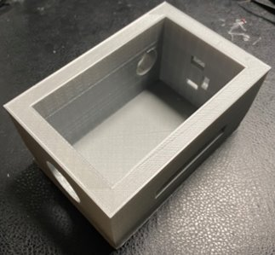

**Assembly and System Integration**

Once all the parts, the PCB, and the enclosure were in (around November 18th), we started work on the assembly of our bop it. The first step in this procedure was to do a dry fit of all the inputs/outputs inside of the enclosure. This entailed mounting the arcade button, slide potentiometer, joystick, key switch, and LCD screen to ensure proper fitment. It was during this time that we realized the design for the LCD screen was a bit off. Due to this, we used some rudimentary hand tools to carve away a bit of the plastic of the lid of the box to allow the LCD screen to fit properly.

Now that we knew all our parts fit the enclosure, we started work on soldering the components onto the PCB. The hardest part of this was determining which resistor/capacitor 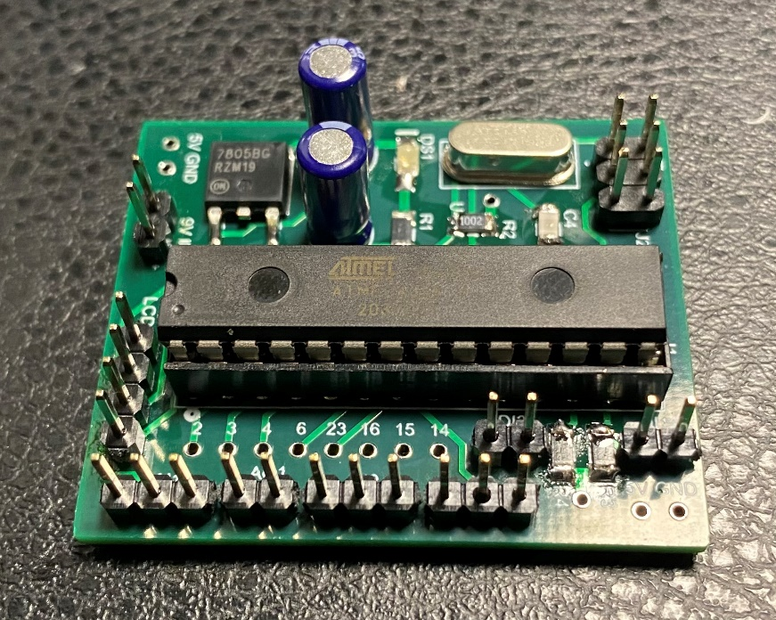went where. Besides for this, the soldering went smoothly. We also decided that, although we added vias that could accept header for pins we were not using, we would leave them empty to conserve room on our PCB. The final assembled version of our PCB is pictured on the left.

After soldering our PCB, we then moved on the adding the female header leads to all our inputs/outputs. This process was very straight forward. Only thing to note here is that we wired the key switch and the battery clip in series with each other, resulting in a 2-wire header to be plugged into the power port of the board. All soldering done to these components were also covered in heat-shrink tubing to avoid any unintended shorting.

Once everything was soldered, it was just a matter of connecting everything to the PCB and flashing a program onto the ATMega. Luckily for us, the first time we attempted to do this, everything worked perfectly! A picture of the final test setup is picture below.

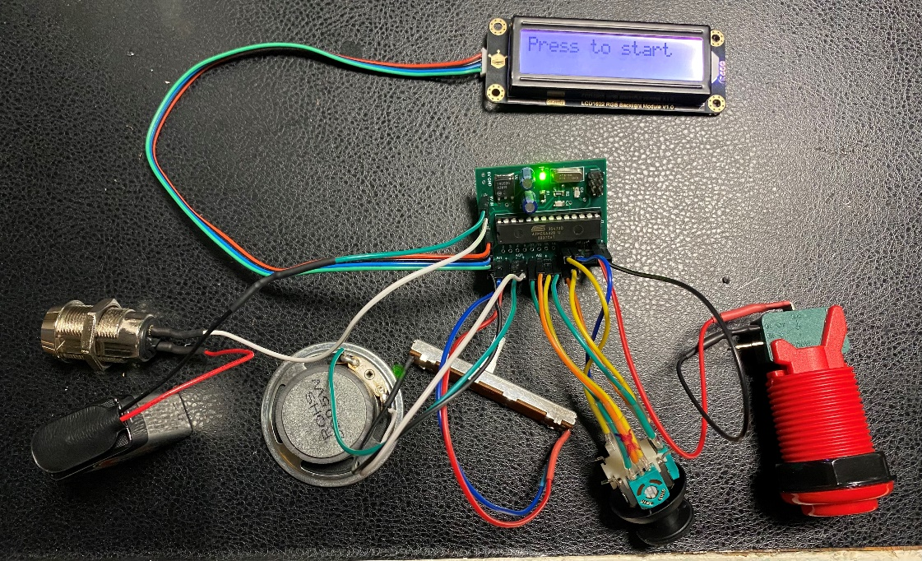

Now that we could confirm all components are working properly together, it was time to put everything into the enclosure. We started by unplugging everything from the board and individually threading the wires through the holes of the box. Before fully seating the parts into their respective recessions, we applied some simple 2-part epoxy to the underside of the component to keep it held into place. Once the epoxy had dried, the bop it was ready to start play testing.

**Design Testing**

Our testing process was not the typical testing process. Since our final parts order, board, and enclosure all came in at the same time (and quite close to our self-imposed deadline), we skipped the breadboard prototype altogether and tested our design on the actual PCB. As stated in the design verification section, we had already written and tested prototype versions of every function included in our final design so all there was left to do was modify those prototypes, slot them into the skeleton of our main code, and see if it worked. Our very first test verified two important things: 1) Our PCB was spot on. The only hardware issues we had were the leads on some of the inputs coming loose from the header pins (which we easily fixed by shifting the position of the board in the enclosure). And 2) our software needed a lot of polish. The most obvious mistake was that we had forgotten to code a failure for incorrect inputs on every function. There were a few minor things, like the screen flash that you see in our demonstration being really fast and jarring, accounting for joystick dead zone created by the cap hitting the side of the box, and miscellaneous display errors. After those were fixed it was time for the fun part: play testing. The initial software was a bare bones version of the final software, not featuring speed increase over time. We opted to wait to include this so that we could get an idea of how hard the game was and how much time was fair. We spend the next few days testing different starting speeds, time percentage decreases, and decrease increments (with the help of a few friends). At the end of testing we were torn between two speeds, one which was slower and seemed more reasonable for new players and one that was faster and felt more fun for veteran players. Instead of choosing one player base over another, we created hard mode. Now the casual mode served to help new users learn the audio cues with the slower speed and inclusion of the visual cues and hard mode would be a test for experienced users with its faster speed and lack of visual cues. At that point, all that was left were small quality of life fixes. The two major ones were syncing the visual and audio cues more closely and removing momentary blank screens. These problems were fixed by moving the audio cue after the visual cue in the code and replacing the characters on the LCD screen instead of clearing then printing.

**Budget and Cost Analysis**

The following cost is for the components used in our single prototype. The cost of the PCB (actually 5) is $12.99. The cost of assembly is ~$1.24. The cost of the components on the PCB is $6.44. The cost of button, joystick, potentiometer, key switch, battery, speaker, and LCD screen are $2.50, $3.95, $1.43, $8.19, $1.90, $2.14 and $11.90 respectively. The total cost of the prototype is $52.68.

The following cost analysis assumes the manufacture of large quantities (1000 units). The cost of the PCB would cost ~$0.20. The cost of assembly would cost ~$1.24. The cost of the components on the PCB would be $3.11. The cost of button, joystick, potentiometer, key switch, battery, speaker, and LCD screen are $2.50, $3.95, $0.78, $5.40, $1.14, $1.21 and $11.90 respectively. The total cost for each unit is $31.43. To make 10,000 units, the cost will be $314,300. However, if we ordered more components at a time, the price would be lower.

**Team**

Our team divided tasks as follows: Alex mainly worked on hardware components (designing and assembling the PCB and compiling the BoM), Anthony focused on writing the software for our design, and Connor drafted, modeled, and printed the enclosure. Since we all lived together, we were able to closely follow each other's progress. This also made meeting and helping each other throughout the design and assembly process easier. We had many small meetings during the project where we would talk about problems or difficulties that we had with our respective tasks. However, we still met at specific times for longer periods to keep us on track to meet our deadlines. In addition, we used a Kanban board to keep track of major tasks and their due dates. We found this to be very helpful and an effective tool to have.

**Timeline**

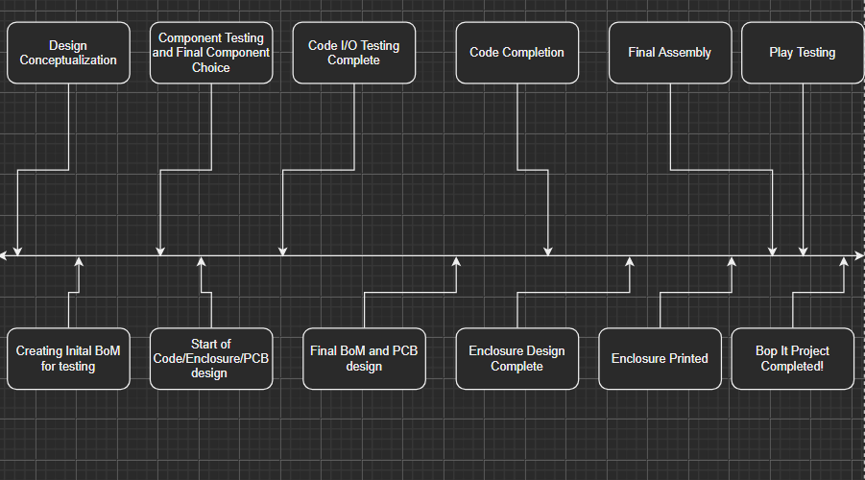

**Summary**

In summary, we are all very pleased with how the Bop It turned out. We felt that all our work put into the project is well represented in the final product. In addition, we now have a much greater understanding for the amount of time and effort something so seemingly simple as a Bop-It takes to create from scratch. If we were to make any changes to our design, it would be to have a more ergonomic enclosure. This would make the game easier to play and handle which is important for a product like this. Another change that we could have made is to have a tune and animation play once you turn on the Bop It or when you win a game in any of the modes. Lastly, we thought it would be cool to add a custom difficulty where you could select the initial time between tasks and the rate at which the time between the tasks changes.